Dad started selling cars for Lou Gerard Ford in Redding after he returned from the service, Circa 1947.
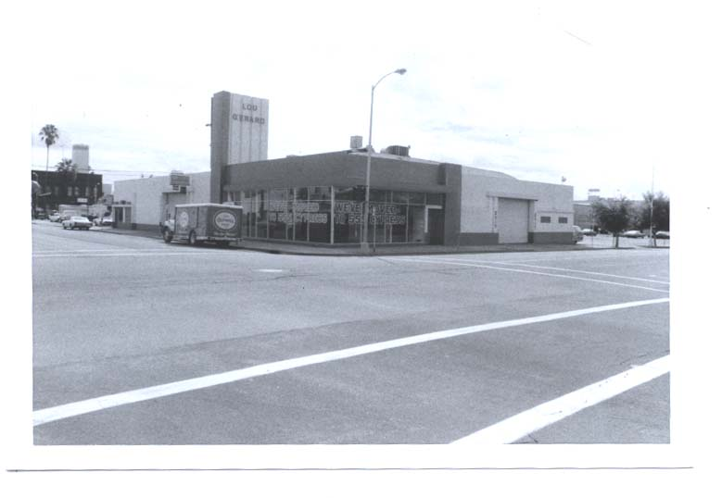
Lou Gerard Auto Dealership, the
eventual home of RPD.

From the Redding Ca. Police Department’s website:
( The end of the 1970's put the Department into the new -- and current -- building, a renovated auto dealership, on the corner of California and Shasta Street)

He became a very young Ford dealer in Dixon, circa 1954- mentioned here from Ron Dupratt Ford’s website:

“Our dealership was established in the 1920's by Charles McGimsey. With a location right in downtown Dixon, McGimsey Ford sold and serviced cars, trucks and like many small dealers, sold gasoline. Mr. McGimsey owned the tin building that he operated from. It consisted of a small showroom, a four bay shop, a small parts room plus a business office. In 1954, the dealership was sold to Doug Dicker who operated it a short time. Dicker then sold to Bob Lawry who also operated it a very short time before selling it to Ron DuPratt. Mr. DuPratt was a recent MBA graduate from the University of Southern California that was quickly dissatisfied with the corporate world. Disliking office politics of the large department store that he was recruited to, he decided that he would work for himself. After trying a number of small business opportunities including a dairy distributorship and the natural gas business, he decided to go into the car business.” -----------------------------------------------------------------------------------------

Dad operated a Ford Dealership in Antioch after Selling the Dixon store. He sold the Antioch dealership in approximately 1956 to Al Eames.

Dad always had an affinity for Chrysler Corporation vehicles-
He then built Doug Dicker Dodge Plymouth in Concord California, across from the Monument bowl.
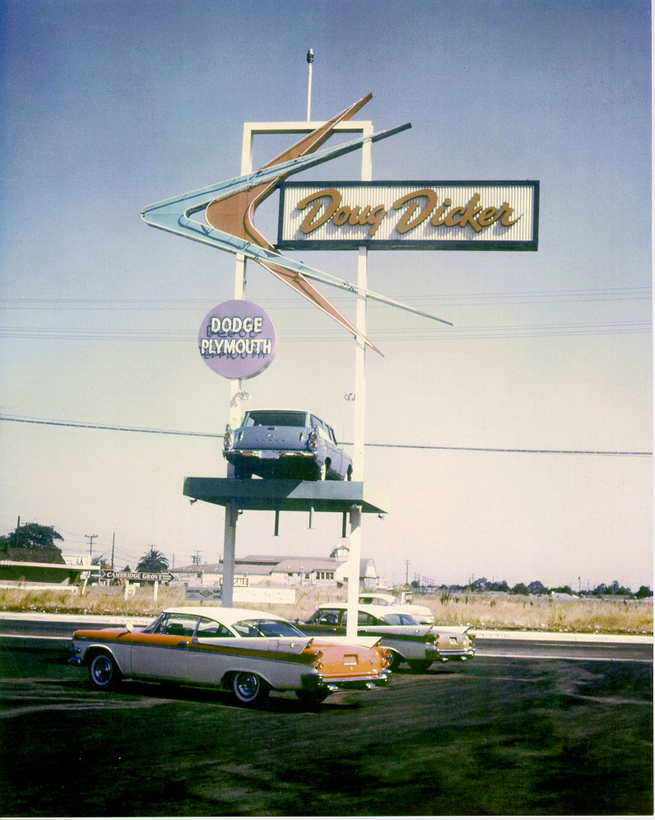

He also sold Fiat, Lancia and Alfa Romeo cars. This dealership was devastated by major flooding.( I thought the date was 1957, but this article states the date was 1958.) Our home in Walnut Creek was badly damaged and I remember we kids were driven away in the night with water up to the headlights of the car. We stayed with relatives elsewhere for what seemed like months until the house was rebuilt.

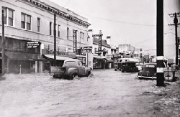
The Flood
1958
On April 2, downtown Walnut Creek suffered a major flood (pictured) that caused over $3 million (equivalent to $22.5 million in 2010) in damages.
--------------------------------------------------------------------------------------------------------
We moved to the San Jose area sometime after that and lived in Cupertino. Dad worked for Ron Ely Rambler in san Jose, Vad Jelton Motors in Oakland, and then took a job at Ames Ford in San Rafael, California in 1960. The family moved to San Rafael in 1961.
-------------------------------------------------------------------------------------------------------
Dad opened and operated a Chrysler Factory facility in approximately 1962, at Geary and Parker in San Francisco. When that was up and functional, he opened Doug Dicker Chrysler Plymouth on Francisco Blvd in San Rafael in 1963. The Old Marin Bay Electric Building needed major refurbishing, and is now the Lexus Used Vehicle outlet.
He eventually moved the facility to a new property located in Corte Madera in 1968.
An interesting tid-bit found in Collecter car ad selling a 1969 Alfa Romeo here:
“ For the Duetto aficionado that is looking for an example that comes complete with excellent documentation of repair history, maintenance records, and other historical information this car will be of considerable interest. Consider the following documents that are included with this Alfa Romeo that provide and interesting and complete picture of the cars past:
* Original California Sales Agreement (Doug Dicker Alfa Romeo Sports Car Center, Corte Madera, CA.) $4525.00
* Original "Pink Slip" (copy provided to new owner)”

Dad returned to San Rafael in 1970, to open Doug Dicker Sports Car Center. He sold his interest in that dealership to his Partner Kip Brown in 1971, and moved to Napa to open
Napa Valley Motors. That dealership was in operation until 1981. He then sold his interest and moved to the Sacramento Area.

He operated Good Chevrolet in Sacramento, and was also a consultant to dealers in California, Colorado and Hawaii.

He also operated Doug Dicker’s Interstate West, an auto brokerage in Sacramento California until his retirement.

